**CCS 101 Final Project Documentation**

Project Name (#)

**Submitted by:**

|  |  |  |  |  |
| --- | --- | --- | --- | --- |
| **No.** | **ID** | **Name** | **Section** | **Mark/5** |
| 1 | 200036304 | Ammar Mohammed shousha | J |  |
| 2 | 200036305 | Mark john | K |  |
| 3 | 200038804 | Amira Nasser | J |  |
| 4 | 200036307 | Yousef elsayed | K |  |
| 5 | 200047914 | Donia Tarek | J |  |
|  |  |  |  |  |

**Supervised by:**

1. Dr. Mohamed Badwi
2. Eng/ …………….

|  |  |  |
| --- | --- | --- |
| **Code /5** | **Documentation /5** | **Presentation /5** |
|  |  |  |

**About Idea:**

An online car shop using HTML

**Code:**

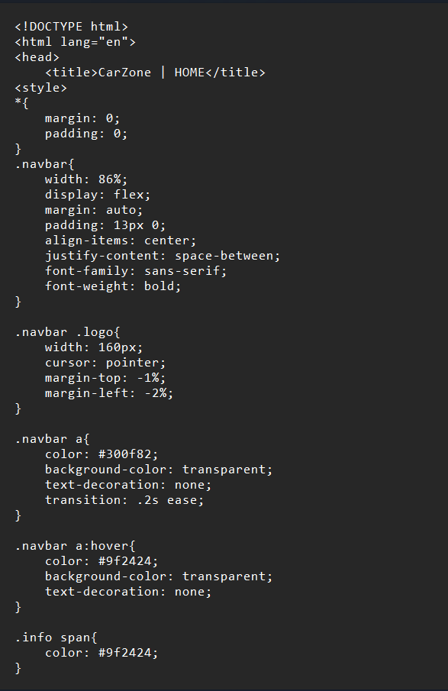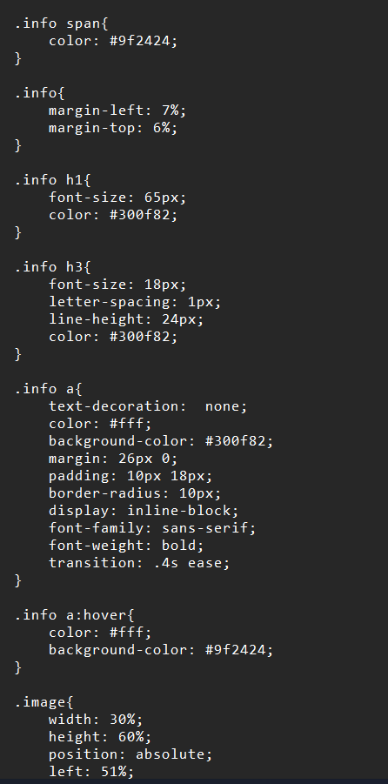

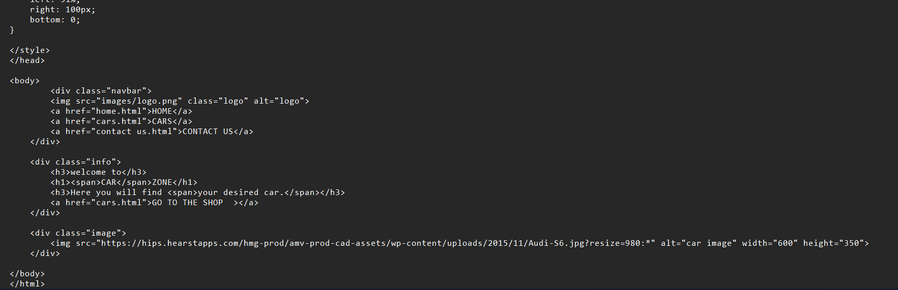

**Output Screenshots:**

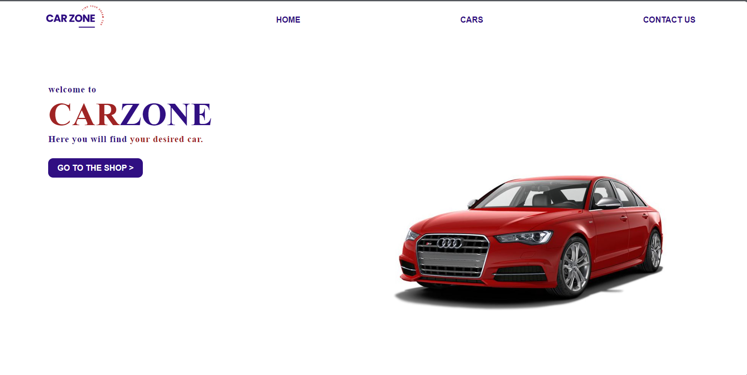

**Code:**

**Output Screenshots:**

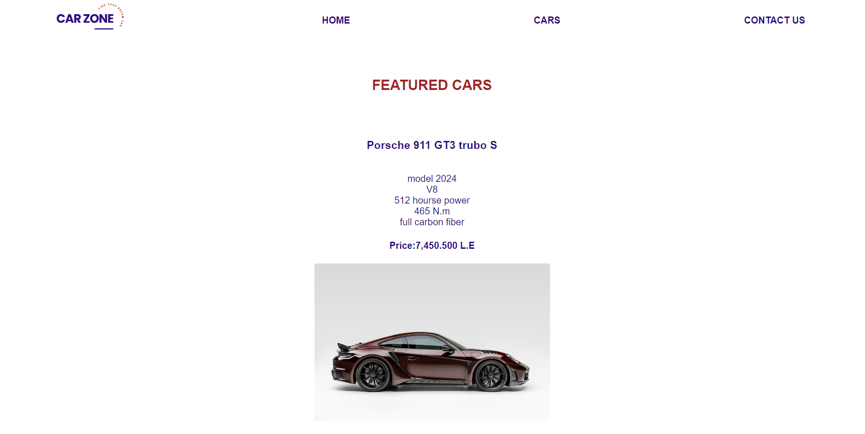



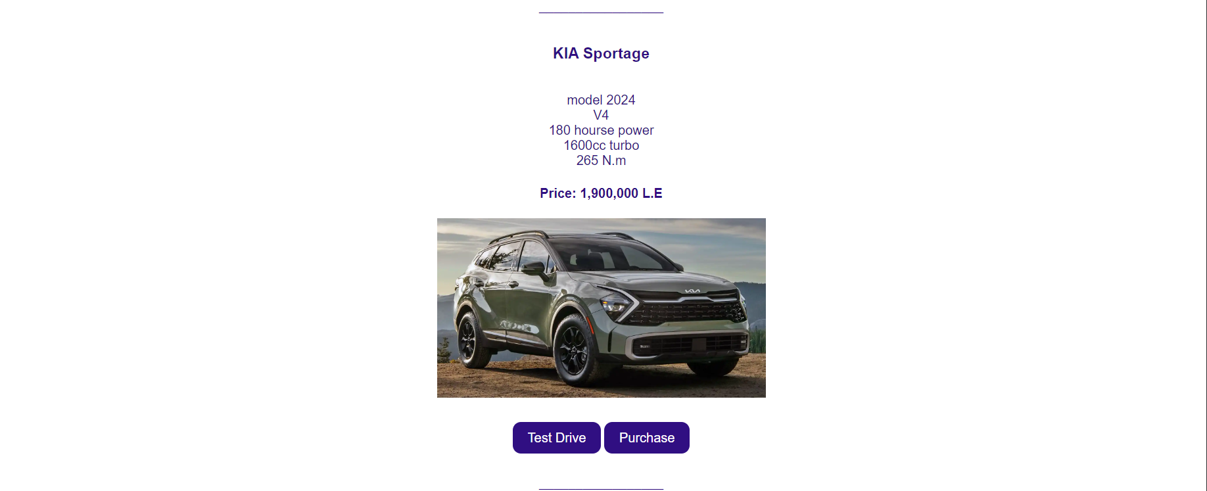

**Code :**

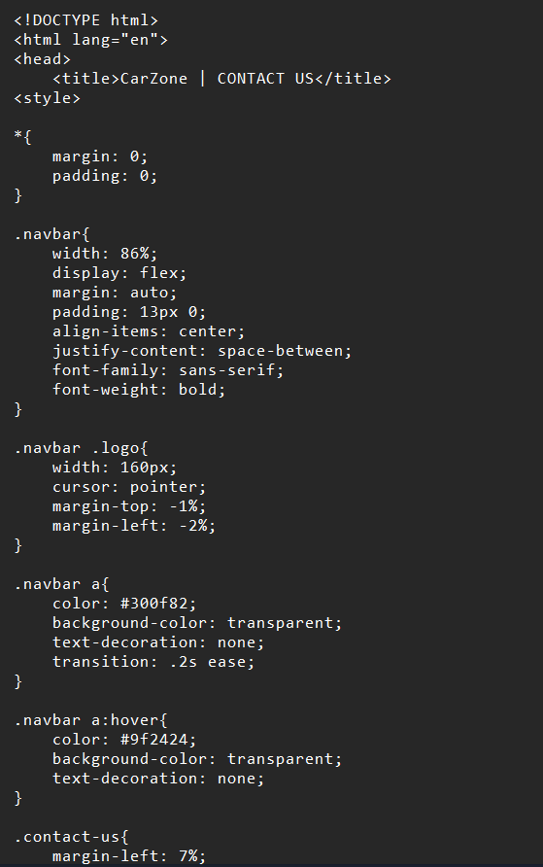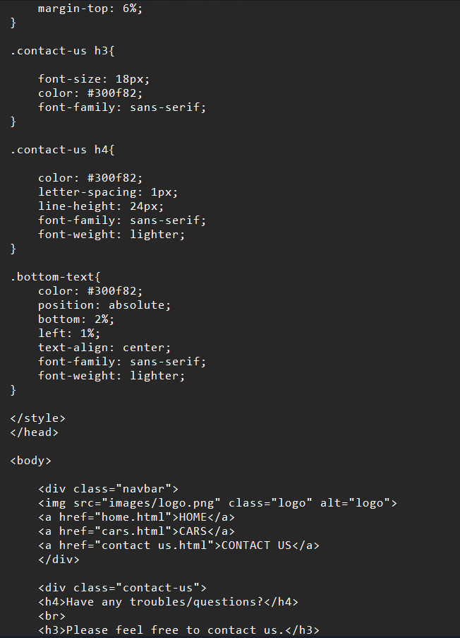

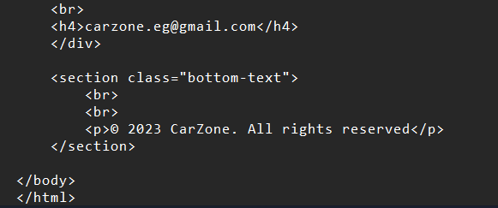

**Output Screenshots:**

